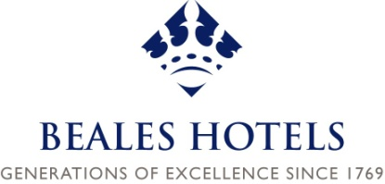


Case Prepared for the STEP Global Research Program

Beales Hotels

Executive Summary

This case examines Beales Hotels, an 8th generation family hotel business, running two four- star hotels and an outside catering operation from premises in North London and Hertfordshire in the United Kingdom.
The company’s origins go back to 1769, when John Beale, a master baker from Royston in Hertfordshire, moved to London and opened a shop on Oxford Street. For eight generations the Beales have engaged in entrepreneurial activities. Their values are encapsulated in the strap line from their logo “Generations of Excellence since 1769”.
Andrew Beale is the current Managing Director (CEO), the eighth generation of the family to run the business. A graduate of geography and hotel management, Andrew took over ten years ago and was the driving force behind the transformation of Hatfield Lodge into Beales Hotel, Hatfield, in 2004. In 2011 Andrew was joined on the board by his younger brother Nick, as a non-executive director of Beales Hotels.
A significant event in recent years was pruning of the family tree. From 22 shareholders in 2008 the present shareholders’ group is two generations of the same branch of the family, Trevor and Susan Beale, their offspring – Andrew, Philippa, Nick and Chris, plus Andrew’s wife Emma and the Beale Trust, which is chaired by cousin Susan Clayton. The Board makes financial and operational decisions and since 2011, consists of Andrew and Nick Beale (NED), Tony King (FD) and Peter Smale (non-exec chair). In 2011, Beales Ltd has a turnover of £5.5m, borrowings of £3m, and a company valuation of £10m. This was reduced from 2008 when the company was valued at £20m.
There is a fairly widespread acceptance that Andrew’s eldest son, Ashley age 17, is the most likely successor. The shareholders have agreed that offspring studying relevant subjects at university could be supported financially. The revitalisation of the shareholders group has, however, engendered a renewed interest and affection for the company by Andrew’s siblings and the family shareholders are currently putting policies and agreements in place to manage succession and family involvement in the company.

INTRODUCTION AND GENERAL INFORMATION

Company Profile

Beales Hotels is an independent, eighth-generation family hotel business, running two four- star hotels and an outside catering operation from premises in North London and Hertfordshire.
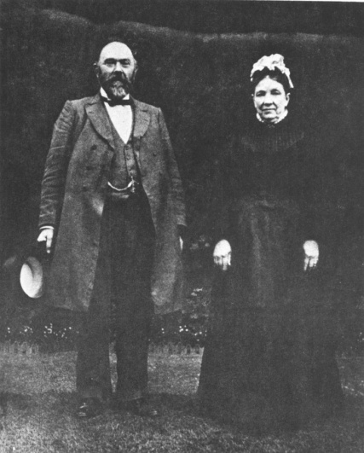
The company’s origins began way back in 1769, when John Beale, a master baker from Royston in Hertfordshire, moved to London and opened a shop on Oxford Street. Successive generations quietly grew the bakery business, but in the 1860s its fortunes really began to rise through the efforts of William Beale, the fourth generation (Figure 1). Rather than let the heat of the baking ovens simply dwindle away, he used their residual warmth to cook dinners, send them out and sell them, thereby creating the first outside catering operation.
Figure 1 William and Christina Beale, circa 1900
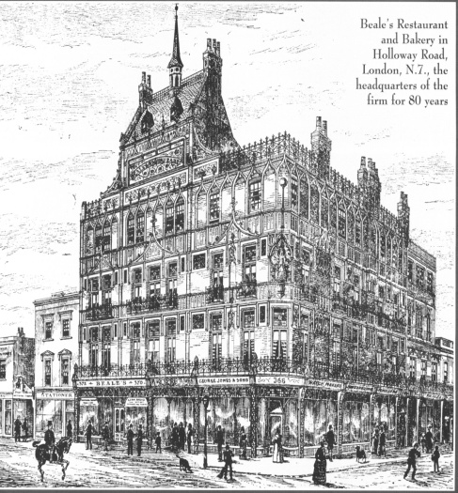
By 1889 he had opened Beale’s Restaurant in a five-storey building in Holloway and complemented his integral restaurant and grill room with a range of food and grocery departments in the same building (figure 2). In 1895 the firm was incorporated as Beales Ltd.
Figure 2 Beales restaurant and Bakery, Holloway Road

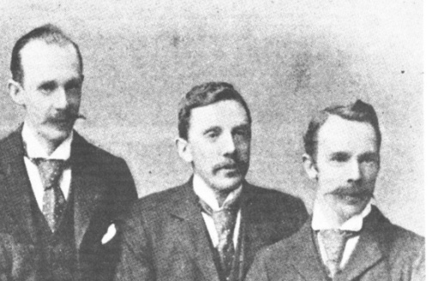
Beales continued to flourish through the fifth generation - William’s sons Thomas, William and Archibald (figure 3) – and the baton was passed on to Thomas’s sons Edward and John in the 1930s. The tumult of the 20th century brought big changes to Beales, though; by the time of the Second World War the grocery, meat and provisions departments had become uneconomical and were subsequently closed down. The bakery side continued to thrive, however, and continued until 1969, when the Holloway premises were sold.
Figure 3 5th Generation – three brothers William Beale b 1864, Thomas Beale b 1866, Archibald Beale b 1872.

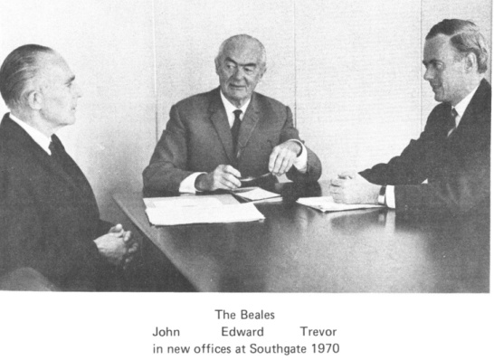
In 1945 Edward Beale had bought West Lodge Park Hotel in Hertfordshire, and moved there to live. At that time the hotel was a quiet, staid sort of place, unlicensed and occupied mainly by permanent residents. Its character didn’t change until 1958 when Edward upgraded the restaurant, opened a bar and began to accept bookings such as wedding receptions. In 1964 the firm purchased Hatfield Lodge, Hertfordshire, a small 26-room hotel, and after several upgrades and transformations this hotel’s present identity is Beales Hotel, Hatfield, a four-star, 53-bedroom establishment. Figure 4 shows the 6th and 7th generation, with Trevor Beale on the right.
Figure 4 6th and 7th Generation
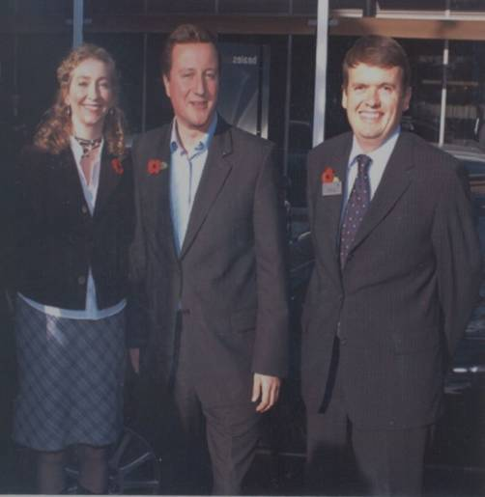
Figure 5 8th Generation, Andrew Beale
Andrew Beale is the current Managing Director (CEO), the eighth generation of the family to run the business. Figure 5 shows Andrew with his wife Emma and UK Prime Minister David Cameron. Andrew took over ten years ago and was the driving force behind the transformation of Hatfield Lodge into Beales Hotel, Hatfield, in 2004. In 2011 Andrew has been joined on the board by his younger brother Nick, who has become a non-executive director of Beales Hotels, the first Beale family member to join the board for fifteen years.

A summary of key dates is provided in Table 1.

Table 1 Key dates for Beales Ltd
Key Dates | Event
1861 | Beales Bakery starts
1861 | Capital of £50
1861 | Borrowings of £200
1861 | Staff of 5
1889 | Holloway Road HQ opens at a cost of £28,000
1890 | Share capital of £75,000 offered to the public
1945 | Lease to West Lodge Park Hotel bought for £9,000
1960 | Purchase of Firs Banqueting Centre for £31,000
1964 | Freehold to Hatfield Lodge Hotel bought for £65,000
1964 | 500 full and part-time staff in the company
1969 | Holloway Road sold to Sainsbury’s for £240,000 and the bakery business all sold
1969 | Turnover reduces by 60% overnight
1992 | Company turnover up to £2.8m
1999 | Sale of the Firs Banqueting centre for £1.25m
1999 | 150 full and part-time staff in the company
2001 | Purchase of Buckingham Beales Hotel for £4m
2001 | 200 full and part-time staff in the company
2004 | Redevelopment of Beales Hotel Hatfield at a cost of £5.5
2004 | Borrowings up to £7m and turnover of £7m
2006 | Sale of Buckingham Beales Hotel for £4.75m
2008 | Turnover at £6m, borrowings of £3m, company valuation £20m
2008 | Further developments at both hotels costing £2m
2011 | Turnover of £5.5m, borrowing of £3m, company valuation £10m
2011 | Further Development at both hotels costing £4m

Group Structure
Beales Ltd comprises the Beales Hotel in Hatfield, the West Lodge Park Hotel and Beales Caterers.

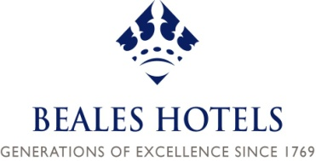

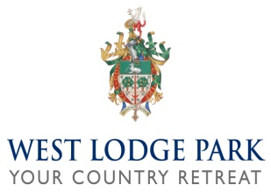


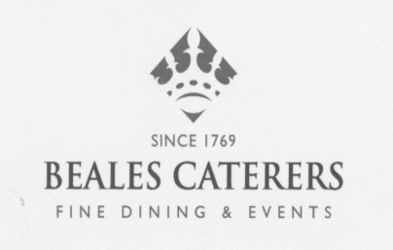

Family profile

The only Beale to hold an active, full-time post in Beales Hotels is Managing Director Andrew, an eighth-generation descendant of founder John Beale, but the imprint of the family is everywhere, in both the buildings and the company. Many of the staff have known and worked for three generations of the family and the family has a distinct presence and standing in the area. Long-serving Finance Director Tony King speaks warmly of Andrew’s grandfather, Edward, or ‘Mr. Ted’ as he was affectionately known: “Ted Beale had his hand on everything but he was such a gentleman,” says Tony. “Trevor (Andrew’s father) wasn’t the same as his dad, but he’s a nice guy and was totally involved in the business, and now there’s Andrew; he’s the hundred mile an hour guy...let’s do it yesterday!”
Having acquired a degree in geography at Lancaster University, Andrew studied hotel management at the renowned Ecole Hoteliere de Lausanne in Switzerland. After gaining experience of hotel work in Canada, New Zealand, Switzerland and the UK he joined Beales full-time in 1992 and became the Managing Director in 2001. One of his younger brothers, Nick, has recently become a non-executive director. None of Andrew’s siblings work in the company. Their offspring are all under the age of 18. The eldest is Andrew’s eldest son, who at the time of interviews (2011) was 17 years old.

Ownership profile

One of the big issues that Beales have had to deal with in recent years has been the increasing number of family members who have come to possess shares. As each successive generation of Beales has gifted or bequeathed shares to their children, the number of family members that were eligible to have a say and a seat on the Board had swelled to 22 by the 21st century. From around 1999 many of the extended family shareholders started to ask about receiving more money from the business. Coincidentally, this was the time when Andrew had to take an extended leave of absence following his first wife’s illness and death. As they were family shares, they couldn’t be traded on the open market and were only worth anything to a fellow family member. Finance Director Tony King expressed the situation as: “None of them had actually bought shares, they’d all just acquired them...but they got a bit...‘we want our money back’.”
After discussion with board members and fellow directors, Andrew saw the requests as an opportunity to streamline the shareholding profile and reduce it to nuclear family members only. The 14 extended family shareholders were offered £2.9million over a 6-year payment period, and the current shareholders are now Andrew and his wife, Trevor and his wife, Andrew’s two brothers and his sister, plus the Beale Trust. The shareholders distribution in 2011 is shown in figure 6.
Tony King begrudges the financial commitment. “It inhibits us, it inhibits us big time,” he says. “We could really, really do without it, we’ve had to borrow to pay it.”
Andrew acknowledges and understands Tony’s feelings about the issue, but declares that the bull had to be grasped by the horns. “We were 22 shareholders but we could have become 40 soon. It’s only a 2-hotel company and it’s not exactly able to support multiple numbers of descendants. £3m is a lot of money to shell out for no return but I had to take the lead and deal with the problem. Clarks Shoes, for example, expanded out to hundreds of shareholders!”

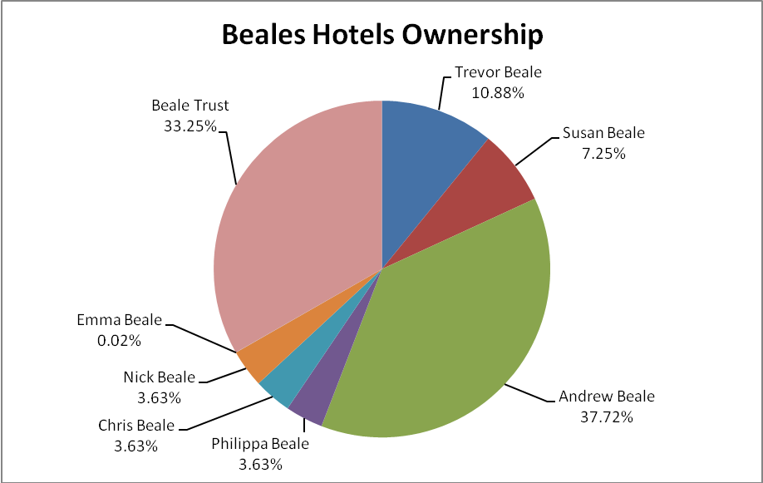
Figure 6. Beales Hotels Ownership

INTERVIEW PROFILES

Five interviews were conducted by Professor Carole Howorth and Jacqui Jackson at West Lodge Park Hotel, Hadley Wood, on 13 May 2011. Four of the interviews were conducted face-to-face with Andrew Beale, Trevor Beale, Dave Seward and Tony King, while the interview with Philippa Beale was conducted via a telephone conference call. Conversations were also held with members of staff. A summary of interviews is provided in table 1.
Table 2 Interview Profiles
Interviewee name | Management Position | Family  Member  (Yes/No) | Generation | Shareholder
Andrew  Beale | Managing  Director | Yes | Eighth | Yes
Trevor  Beale | Former  Managing  Director | Yes | Seventh | Yes
Philippa  Beale | None | Yes | Eighth | Yes
Tony  King | Finance  Director | No | N/A | No
Dave  Seward | General Manager | No | N/A | No

All the interviews were conducted in or from the same location and interview times ranged between 30 minutes and 1 hour. Andrew Beale has also presented the story of the family business to undergraduate students at Lancaster University, which was audio and video recorded. The Beales website is comprehensive and includes a history of the family business, written by John Beale, which was also provided to us in book form.

INDUSTRY DESCRIPTION

Hertfordshire hosts a total of over 120 hotels within its county boundaries and the two Beales hotels have consistently been rated in the top five by both consumer websites and industry watchdogs such as the AA and Trip Advisor, frequently occupying positions 1 and 2. The company’s intention for some years has been to fashion the hotels as high-class, 4-star establishments and to maintain their status and reputation. Beales have owned The Firs Banqueting Centre and the 3-star Buckingham Beales Hotel, but the management believe that 3-star hotels offer a difficult business model for the foreseeable future and that the 4-star experience is what they excel at.
Finance Director Tony King explains the change in the hotel market in the last 20 years or so: “2-star hotels have squeezed up and the 3-star is neither here nor there now because you’ve got all the Travel Lodges and suchlike everywhere, which used to be known as 2-stars but they’re not now, they’ve all improved. When we knocked Hatfield Lodge (now Beale’s, Hatfield) down in 2004, we started off building a 3-star hotel and by the time we finished we had a 4-star hotel. Andrew took the decisions...a 4-star hotel’s not going to be squeezed in the market and that’s what it’s all about.”
“Lodge nights, ladies nights, dinner dances for Rotary clubs, the Round Table, 41 clubs, all those things that back in the 1970s and 80s everyone went to and was a member of...as time went on these functions dropped off and the lodges disappeared. When it got to 2000 we realised that banqueting was going down and down; we sold The Firs in 2000 that was a big banqueting centre. We bought the Buckingham Beale Hotel in 2001/02, but we realised that it was never going to be a 4-star hotel, so we sold it in 2006.”
The recession period was not easy for the Hotel industry. Tony King pinpointed the Forneston group, who had recently gone into administration, while Trevor Beale talks about the prestigious Von Essen group, owners of Cliveden and the Royal Crescent at Bath, who have suffered the same fate.
Andrew Beale is very clear about where he believes is the right market position for the hotels at the current time, and his senior staff agree with him and support his judgment. Although some social trends appear to have altered greatly in recent times, as Tony King observes above, there is still a great desire for friendship groups, and particularly family groups, to congregate in large numbers and a good hotel is seen as the prime venue for this type of gathering. “I think there is a sense of place and rootedness that people relate to with a hotel,” says Andrew, “in a world which is getting evermore frantic and scattered and everything. A place where Nan had her 70th and Mum got married...30 years ago everyone would have been in the local area, whereas now people are coming from Australia or wherever so hotels benefit from that.”
The ways of communicating with existing and potential customers has inevitably changed with the rise of social media, but Beales are aware of this and have got on the bus. “We did an offer, through Facebook, for our Hatfield restaurant recently, and within 24 hours we sold 574 covers,” said Andrew. “Social networking is the kind of thing that we are doing now.”

ENVIRONMENT

Hadley Wood is at the outermost edge of Greater London and is possibly the most northerly London borough, while Hatfield is in the borough of Welwyn Hatfield. Both are stated on the Beales Hotels website as being situated in Hertfordshire.
Hadley Wood is home to a glittering list of luminaries: nearly half of the Tottenham Hotspur football team live there and they share the neighbourhood with Cheryl Cole, Emma Bunton, Sir Ian Hunter and Lennox Lewis. The famous Patti Boyd, former wife of both George Harrison and Eric Clapton and subject of classic rock songs like Layla and Something, lived in the area until adulthood.
Hatfield cannot boast as many well-known sportspeople among its habitants, but former residents include ex-footballer Rodney Marsh, film director Guy Ritchie, folk singer Donovan and romantic novelist Barbara Cartland. Even Queen Elizabeth 1st lived for a time at Hatfield Palace.
The University of Hertfordshire is based in Hatfield, and several large organisations have a base in the town, including Porsche, BDO Stoy Hayward and Everything Everywhere (parent company of T-Mobile). Hadley Wood is very much a residential suburb, but it lays claim to a 400-acre country park and a golf club.
The geographer in Andrew Beale finds the local landscape ‘relatively uninteresting’. “It’s the edge of London, Lake District it ain’t,” he says. “Because of that you’ve got to make another narrative and perhaps a more interesting one. I think people like family business...in fact I don’t think it, I know it. One person said on a website recently: “this place has been in my family forever.” They’ve had all their family events here, all their big family moments in life...I think that (narrative) works very well.”
Of the 120-plus hotels in Hertfordshire, only 2% are 5-star but 22% are 4-star and the Beales aim is to keep West Lodge Park and the Beales Hotel right at the top of every performance and customer satisfaction measurement. Despite the recession – which Tony King believes to be the biggest economic downturn they’ve been through – the company is determined to keep the standard and quality of their customers’ hotel experience at the highest level. Location doesn’t seem to have the fundamental importance in this field that it once had: quality of service and affection for a non-homogenised institution seem to be of equal consideration.

OWNERSHIP DYNAMICS

For a business to survive for nearly a quarter of a millennium is a huge achievement for any company, but for a concern to continue through eight generations of the same family, without any injection of external capital, is remarkable. The history of the company tells of changes in direction and diversification, but there doesn’t seem to have been any catastrophes or major fall-outs between family members. Over the course of eight generations there have been two ‘prunings’, or rationalisation of shareholders, once in the mid-1930s and then again within the last three years.
The recent shareholder re-organisation was a huge event for the company, both in its conception and in its consequences, but it seems to have been effected with a minimum of discord within the family. The staff seem to be more upset about it than the family. “We’ve taken a hard decision,” says Andrew. “I am sure Tony (King) would have said that he begrudged it, but I had to take the lead in terms of seeing the history and the danger of dilution.”
Philippa Beale, although having no active day-to-day role within Beales, feels that the streamlining has been a good thing for her. “I would come along to the AGMs and the other meetings and there would be something like 20 shareholders. I didn’t feel like I had anything relevant to contribute, so although I enjoyed being part of the meeting I didn’t feel I was contributing very much.”
“Now the feeling of that has changed slightly, since the reorganisation. In the last meeting, after the AGM, it was a much smaller group. We had a half-day meeting so we could really get more into the issues and we were talking about what we saw as the future of the business... what kind of values we wanted to have and it felt like a very different sort of meeting, in which everybody could contribute something useful.”
The offer to the extended family shareholders was an ‘all-or-nothing’ one: they either all accepted it and had their entire shareholding bought out or it wouldn’t happen at all. There is no record of any dissenting or disgruntled voices; even Susan Clayton, who was apparently the most vocal of the group in asking for settlement, has remained as chair of the Beale Trust, so she maintains a forward relationship with the family.

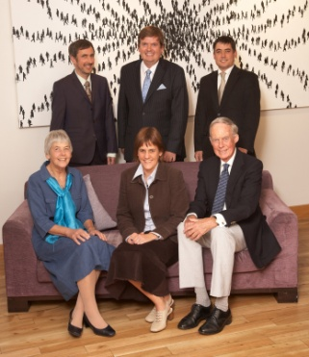
As mentioned earlier, the present shareholders’ group is Trevor and Susan Beale’s family – Andrew, Philippa, Nick, Chris, plus Andrew’s wife Emma and the chair of the Beale Trust. At the time of the reorganisation there was talk of restricting the group to ‘blood only’ but that would have meant excluding Andrew’s mother, so she and Andrew’s wife were included in the new group. A recent family shareholders photo is shown in figure 7.
Figure 7 (Back row, A, Andrew, B, Front row: C, D, and Trevor Beale

At the first meeting of the new shareholders’ group, Andrew’s brothers aired an historic ‘grudge’, namely that they hadn’t been invited to join the business. Both would have declined such an offer, but they would have liked to have been asked. Andrew acknowledged their point and instituted an open discussion forum, to include members of the next generation. Since then Nick Beale has become a non-executive director.

OVERLAPS IN FAMILY AND FIRM LIFE STAGES

The Beale heritage is very tangible, in the hotel and in the local community. There are portraits of Beales past on the hotel walls, the presence of predecessors such as ‘Mr. Ted’, Trevor’s father, is still very real in West Lodge Park – family and staff show visitors where his office and living quarters were – and long-serving staff attribute their length of service in no small part to the fact that Beales remains a family business.
Philippa Beale tells of the resonance of the Beale name in the area. “My grandfather was quite an esteemed kind of man, well thought-of...went to the church and did a lot for Rotary...so I guess he had a reputation.” The community values which Edward Beale held are reflected in the fact that West Lodge Park is the first choice of venue for scores of local people when they hold their family get-togethers. “The hotel has a reputation locally,” continues Philippa. “It seems to be a place where people will come – local people – and have their annual events or life celebrations.”
Edward Beale seemed to eat, sleep and drink West Lodge Park, even after he’d long since retired. In 1992, when he was 88, he would still, Andrew recollects, have breakfast in the restaurant at 8am every morning. “He’d go round the tables, suited and booted, talking to all the customers, then he’d go out for a walk in the arboretum which was his baby as well; he’d talk to people there and take them round.”
Although such whole-life dedication writes an anthology of endearingly eccentric anecdotes in the family memory bank, it is not an example that Andrew or his father have tried to emulate. “My father made a very early decision not to grow up his family on-site and I have carried that on. I’ve got other interests outside of here, so that occupies some of my time. I’ve seen it so many times, business people who are absolutely defined 100% by what they do: my grandfather was Mr. West Lodge Park in every grain of his being. I play the cello, I’m chair of a rather large charity in Luton, I’m active in my church...the point is that if something happened in the business I know that at least there are other things to fall back on. My father was a good role model in that respect.”
Another influence on Andrew’s policy of living off site is the relationship that he has with his staff. “I could be driving everybody nuts, totally...my attention to detail, or interference, depending on how you look at it. I deliberately live away so I am not quite in their faces all the time and they breathe a sigh of relief when I’m gone, no doubt. We have general managers here who can cope.”

ORGANIZATIONAL CULTURE: the view of non-family managers

The hotel industry contains many large companies whose branding is designed to be recognisable - Premier Inn, Holiday Inn, Best Western; many consumers favour a name that they know and trust but many more deliberately avoid a corporate logo and seek out something more individual.
Industry workers often think along the same lines: some hotel employees love to work within a tried and tested system, where everyone’s role is clear-cut, but others could not contemplate working in such an environment. General Manager Dave Seward is such a man.
Born and raised in Zimbabwe by parents who were born in Britain, Dave left school and began a 3-year apprenticeship at Victoria Falls Hotel, a big corporate chain of hotels in Southern Africa. Dave stayed in the industry but the collapse of Zimbabwe meant that the flow of tourists visiting that country shrank to a trickle. Uprooting your family is never an easy option, but Dave and his wife saw no option and they moved to Britain with their three children in 2001.
Marks and Spencer was Dave’s first employer in the UK, but he soon managed to get a position at Beales’ Buckingham Hotel as Food and Beverage Manager. Three months later he was promoted to General Manager and he has been with Beales ever since, for the first six years at the Buckingham Beales Hotel and since then at West Lodge Park.
One of Dave’s employers in Zimbabwe was the Landowes family, who owned a small number of hotels, including one in Kariba on the banks of the Zambezi River. Dave worked there for seven years and he and his wife lived on site and brought up their children there, in the game park attached to the hotel. The Zambezi and the Hertfordshire commuter belt may appear to have little in common, but for Dave it was like being back on familiar ground. “After a while I realised that I was back into that sort of environment, that I was back on my feet really...that I was lucky to be there. When you find a company with good morals, and this company has passed down through eight generations, for example, you’ve got a bit of security there. I’m a family man and I just feel that there’s a bit of security in that they put people first, as opposed to profit and loss accounts...they care about individuals and that’s the kind of person that I am.”
Dave’s experience in the industry in both the UK and Zimbabwe could probably earn him a senior position with one of the big hotel groups, but the culture of a large organisation is not something that he cares for. “I have worked in a big company where you are nothing but a number, and that’s not me, I’m a people person. Andrew runs the business but we’ve got a very good compromise. We can clash over the smallest things and he will say ‘I disagree with you’ but we will find a compromise. It’s about respect, respect for each other.”
Dave highlights the value of ‘respect’. He talks about compatriots who arrived in the UK at the same time as he did, that some of them have had it hard: “They may have been paid more and they may have better perks but my job has given me everything I want...to be treated with respect and, you know, treated as a person.”
There is a huge lexicon of business words from which companies of all sizes fashion phrases that they use to describe themselves and the culture that they espouse: dynamic, stunning, professional, imaginative, forward-thinking, inclusive, the list is enormous. The word that Andrew Beale says that they omit, but is the one that makes his business special, is love. Love? “It’s an interesting word,” says Andrew. “No-one talks about love in business, but love for a business is something which someone who isn’t a family member will never quite have. I’ve got the love for this business but it’s been in me for many, many years now. I love the staff, the fabric of the place, the customers.”

ENTREPRENEURIAL ORIENTATION

- Autonomy
Dave Seward has two Zimbabwean friends who are now running British hotels. One of them only sees his boss every six months and has free reign on a day-to-day basis, but he wouldn’t swap positions with them. “I believe there would be more autonomy elsewhere, but I know there is that security here, that if there are any major decisions in Andrew and whoever’s heads, because we’ve got such a good relationship, I would know of them sooner or later rather than a memo.
“In a corporate environment you do as you’re told basically. Memo on desk, that’s the boss’s decision, that’s it, whereas here we are allowed to discuss and debate.”
Tony King concurs about the general level of discussion. “We talk about everything, we really do...I mean, on the financial side there are things that Andrew doesn’t know, only because I think he doesn’t need to know the detail, but in general we talk about most things, or I assume we do. He’ll run something past me and say ‘well, I want your backing on that’ and I might say ‘well, I’m not sure about that’! He does like to get people’s backing, though; he wouldn’t just come out with something cold to everybody.”
Although senior managers like Dave Seward and fellow directors like Tony King attest to the open forum culture, there is no getting away from the fact that the business is still, in Dave Seward’s words, ‘Andrew’s baby’, a fact which leads Andrew to reflect on his style of leadership.
“I would like to think it’s not me making all the decisions...I don’t know whether the staff perceive that I do make all the decisions, but there are several bits to my leadership. There is the strategic stuff, the long-term picture stuff, then in the middle there is the kind of day-to-day management...the minutiae. In other types of business you can be the ‘leader’, the strategist, but in this particular business attention to detail is terribly difficult to get right and one has to get involved in it.
“Is my style of leadership right for all the staff? No; it’s right for those who understand that kind-of unusual relationship that’s in a family business, but it’s wrong for those staff who have come in from a corporate background.”
- Innovativeness
William Beale, the fourth-generation descendant of the founder John Beale, was the first member of the family to take the business in a significantly new direction. The first three Beales had carried on the founder’s trade of baking from a succession of premises, but William saw that the ovens might be used for more than just baking, and that the great heat they generated was a potential resource. His decision to start using them to inaugurate an outside catering business was the first significant example of innovativeness in the company’s history, but the spirit of innovation has flourished many times since.
On the baking side, Thomas – fifth-generation – enhanced the passed-down family wisdom by training at the Jockey Club in Paris. He won many prizes for his confectionery and improved the company’s product range and reputation.
Thomas’s son Edward grasped the baton of innovation by developing the hotel that he had bought as a residence and an interesting business proposition. Concluding that the bakery business might not thrive into a third century of trading, he transformed West Lodge Park into a venue where people could not only stay but also hold wedding receptions, banquets, dinners and dances. The Firs was purchased in 1960, soon after the expansion of West Lodge Park, and Hatfield Lodge became the third Beales hotel in 1964.
Even in his retirement Edward Beale continued to innovate: the Beale arboretum was his idea and has proved to be a real asset to West Lodge Park.
Introducing innovation can be tricky in any business, particularly one that is steeped in tradition as much as the Beales is. Some of the customers can regard the enterprise as though they have a personal share in it, as Dave Seward testifies: “The menu has had to change, become more modern and contemporary, and we’ve now got burgers on it, but we’ve got a couple who’ve been coming here for years, saying ‘A burger on the menu? We’re going to see Mr. Beale!’”
When the big change happened, however – when Hatfield Lodge was knocked down – the customers seemed to accept it relatively happily, as Tony King recalls: “I was at Hatfield for years and years and we had a great team...all that atmosphere and family feeling, but when we knocked it down all that atmosphere had gone. That didn’t last, though; the residents that used to be there came back...it comes from the staff being happy, being part of the family.”
Andrew remains open to innovativeness and new ideas; he’s aware of the innovations that previous generations introduced, but he will bring in his own changes if he believes them to be for the good of the business.
- Risk-taking
“Andrew’s the risk taker, Tony is the man with his feet firmly on the ground,” declares Dave Seward. “Andrew likes the gamble; we spend a lot on getting the rooms done, we’ve got to be the best, have the highest standards in the area.”
In Dave’s opinion, this isn’t a trait that he inherited from his father, Trevor: “I think his father was very, very cautious...I think he wasn’t a great spender. Andrew, on the other hand, isn’t cautious...money is all pumped back into the business.”
Despite this assessment of Trevor as a risk taker, it was under his stewardship that the great risk was taken, namely shutting the bakery and the twelve shops and thereby calling time on 200 years of tradition. “I was sorry for my uncle,” says Trevor. “We know the business went back to 1769 as bakers, not hoteliers, but in practice it was the right decision. Private bakers in London now are struggling, everybody gets their bread from the supermarkets, which were just beginning to knuckle into our business at the time.”
At that point there were three Beales in executive director positions – Edward, John and Trevor, and all three were in agreement on the way forward. “My vision was accepted at the time by my uncle with very good grace,” says Trevor. “Both he and my father could see the problems with the Holloway business.”
Events and trends undeniably shape planning in any business, but departing from a formula inevitably involves risk. Tony King described, earlier, the decline of the lodge meetings and the Rotary dinner-dances that the Firs used to thrive on, but the difficulty was in making the right decision as to where to position the hotels in the 21st century.
“Hotels are difficult businesses to take risks in,” says Andrew Beale. “They’re so capital intensive. We took a risk with Hatfield when we knocked it down; I had this ‘road to Damascus’ type moment when I woke up one day and thought ‘I’ve never actually liked to stay in that hotel because it was 3-star middling. Let’s just get rid of it and start again.’
“That was a risk involving about £5m of new build; it could have fallen flat and gone wrong but it hasn’t done so.”
- Proactiveness
Both of the Beales hotels are consistently ranked highly in hotel industry league tables and they maintain a loyal customer base. Customer profiles are not a static thing, however, as the decline of the dinner-dance culture shows. Proactiveness for the Beales starts with keeping a keen eye on the competition. All of the senior management visit rival establishments to check what the opposition are up to. Non-executive chairman Peter Smale keeps Beales up to speed with what’s trendy in the capital. “He’s quite trendy in terms of London food and catering,” says Dave Seward. “It’s good to have someone who is from the outside who can look at the situation with fresh ideas and say ‘well, actually you’re wrong.’”
Although Tony King has a reputation for being rather parsimonious, he goes on holiday to 5-star or even 7-star hotels – in the interests of research, of course – while Andrew often stays in Premier Lodge-style establishments. “Andrew’s got 3 kids to look after, I haven’t!” explains Tony. “We’re always looking at things...we read a lot, we go out and visit other hotels.”
Social networking now forms a key weapon in Beales’ proactiveness: Andrew speaks proudly of a Facebook offer which generated over 500 restaurant bookings in a 24-hour period. “That’s the kind of thing we are doing now,” he says. We’ve spent 2.7% of our income on marketing in the last year, which is slightly less than the industry average of 3%, but Travel Lodge and Premier Inn-type places spend about 5% of their revenue, chasing business all the time. They’re very price-led and very successful at what they do, which is all the more reason for us to go upmarket and differentiate even more from those kind of places.”
Trevor Beale used to travel round and visit country hotels, armed with a tape measure. “I used to measure up bedrooms and bathrooms to find out what sort of size was right for the new bedrooms here,” he recalls. There doesn’t seem to have been as much breadth of input from staff during Trevor’s tenure, which perhaps reflect his style. “I don’t think there were a lot of ideas from members of staff...I think any ideas involving change would come from myself or my finance director.”
- Competitive Aggressiveness
“If we don’t compete ferociously for business then it will go somewhere else,” says Andrew bullishly. “It is a frantic market out there and there may not be enough business for every hotel. We end up negotiating hard on rates – bedroom rates, conference rates – we do lots of offers, special offers at different times of the year...it’s constant.”
Flexible rates have been a source of controversy amongst Beales’ competitors, as Dave Seward explains: “I’ve been playing a rate game for some time...on a Sunday night we’ve lowered our rates considerably, so much so that our competition have phoned Andrew to say Tuesday we are right up there again; you’ve got to be really careful because you get people coming in saying ‘last week I paid £60, you are now charging me £110’, so it’s got to be gradual, you’ve got to have a strategy.
“We can all lower our rates and become Premier Lodge, but that’s not what we are about, we’ve got our techniques and our unique selling points. We’ve never gone for these crazy, crazy rates but it’s give and take sometimes – we’ll do special deals, lots of special menus...you know, lunch for £10 and things that are sort-of ‘not West Lodge Park’, but they’ve worked and now we’ve adopted them.”
Tony King says that the Beales’ competition is mostly in Hertfordshire, that the London scene doesn’t really affect them. “We tend to find it’s the local hotels we’re competing against – in Enfield, Watford and Hatfield. It’s very localised and it’s about keeping in touch with an awful lot of other companies, especially in Hatfield.
“There are networking lunches and things like that, we go to lunches at the Hertfordshire Chamber of Commerce or the North London Chamber of Commerce. As well as the Chambers of Commerce we are members of the Conservative Association; they spend a lot of money with us and the MPs come, so there is that kind of knock-on effect.”

FAMILINESS AND FAMILY RESOURCE POOL

A) Leadership
Each generation of Beales seems to have employed a different leadership style. There was the go-ahead, energetic approach of William Beale in the 1860s, the patrician character of ‘Mr. Ted’, Edward Beale, the steady yet business-transforming direction of Trevor Beale. Now there is Andrew. All the interviewees testify unequivocally that he leads from the front, but there is no doubt that he doesn’t leave anyone behind; he very much favours a co-operative, collaborative culture, something that pleases Philippa Beale greatly.
“Andrew has done tremendously well, it’s clear that he knows what he’s on about and that’s why there hasn’t been a real need to get involved,” she says. “I would come along to the AGMs but we’d be a much bigger meeting, something like 20 shareholders. I didn’t feel that I had anything relevant to contribute.
“Since the re-organisation the shareholders group is much smaller and I feel more involved. The first meeting was chaired by Nick – Andrew specifically wanted someone else to chair it – and Nick chaired it very well. I think it was probably the first time that some of us had contributed anything very much, so it did have a different flavour to it.”
The Board of the Beales Group consists of Andrew, Tony King, non-executive director Nick Beale and non-executive chairman Peter Smale. Decisions are taken corporately, although Andrew says that he generates most of the ideas and the others help to put them into practice. “We have frequent rows in the Board over expenditure. Tony has said that he has managed to slow me down from 100 miles an hour to 80 miles an hour and that’s one way of looking at it.” On reviewing the interview write-up, Andrew added “In 20 years we have gone from two hotels and a banqueting centre to, er, two hotels, hardly a turbo-charged pace.”
Tony King sees the situation differently, he describes the process as himself and Peter trying to temper Andrew’s excesses. “Peter’s a good sounding board,” he says. “Andrew comes across as quite strong at times, saying ‘we need to do this, we need to do that’, so sometimes I need to speak to Peter and say ‘Peter, what do you think?’”
Dave Seward gets along very well with Andrew, and one reason may be that they are similar characters, as Tony King observes: “Dave’s a real leader, he’s brilliant with his staff, he’ll get them to walk over hot coals somehow for no pay at all. Quite a few of them came here from Buckingham, even years after we’d sold it.”
Andrew is acknowledged by his staff to be a forceful character but none of the other management seem to be intimidated by his leadership style. They will all stand their ground and make their feelings known. One factor that none of them have had to worry about is day-to-day interference from Andrew’s predecessor; when Trevor ceded control to his son he left the engine room completely.
At the time, Andrew viewed his father’s departure as rather abrupt but when he was made Managing Director he became the Beale-in-residence; while Trevor was MD his father was Chairman, a role he occupied until he was in sight of his 90th birthday.
Philippa considers the leadership to be very much in Andrew’s hands and not influenced on an operational level by the preceding generation. “My dad doesn’t dominate at all; he wanted Andrew to take on the mantle and leadership of the hotel, and he very much stepped back when Andrew took over.”
B) Networks
The Beales family are extensively networked and proactively develop social, charity and business connections. Trevor was chairman of both the BHA London Hotels Division and the London Hotel Managers Association whilst he was Managing Director; Andrew, Dave and Tony are all involved with the Hertfordshire Chamber of Commerce and the North London Conservative Association. Networking is not seen as part of the marketing strategy but they do see the importance of getting ‘out there’: “Some family businesses kind-of get dreadfully inward looking,” says Andrew. “I don’t class us in that respect at all, in fact we are almost the contrary. I think we are outward looking, I think we are a quite open business.”
Dave Seward states that ‘everyone knows Andrew Beale’, that the family’s reputation in the area is very high. “Everyone knows a friend of Andrew Beale’s, his name gets thrown about quite a lot,” says Dave. “You just have to mention West Lodge Park and it’s associated with the family immediately.” Such a high profile is partly to do with the work that successive generations of Beales have put in to maintain the standards of their hotels, but also because of the continuing renown of the family name. “Our competition here, the Royal Chase,” explains Dave, “they’re a family business, they’ve been going for many years, but they’re not the same, they’re not eight generations. Our level of standards here, we do well. If there’s any complaint, Andrew answers it personally.”
The enduring, existing customer base is hugely important to the Beales and a lot of their marketing efforts are aimed at the network of customers, who are often families,that have been coming to the hotels for decades. Whilst Andrew sees the new media phenomenon as being very exciting, he feels that a lot of custom generated by these methods may be fickle, but the families who have been patronising West Lodge Park for 30 years or more belong to a special kind of network that must continue to be catered for. “You don’t need to spend money on marketing to this kind of customer because they are already with you, they are a loyal market. What you need to concentrate on is looking after them when they are here; offering value for money, good staffing, prompt service.”
C) Financial Capital
The exact percentages of how many shares each party has is unclear for some of the members; neither Philippa nor Trevor know the size of each shareholding, only that Andrew has more; whether that has come about because of his position isn’t clear. The Beale Trust, set up by Trevor’s Uncle John because he only had one daughter and he felt that he wanted to do something more with the shares, owns a third of the company. Whatever dividends the Trust earns are issued proportionately, to charities nominated by individual shareholders.
The Trust’s allocation of funds doesn’t impact on the working capital of the company. Ever since John Beale began trading from Oxford Street in 1769, Beales have never needed to trade capital for equity. The recession continues to have an effect and the shareholder rationalisation has come at a substantial cost, but seems to be manageable nevertheless.
Tony King says that the overdraft recently hit a peak, and that existing loans run to several million pounds, but he remains confident of controlling the operational seesaw that he and Andrew ride. “It’s got to the stage where I’ve got to be the settling one,” he says. “I need to say NO we can’t afford that and Andrew will say YES we can and I will give him a little bit and take a bit back. It has to work that way because otherwise we wouldn’t survive, because Andrew....whooosh gone...and that’s why the two of us work well.” A summary of financial information is provided in table 1.
Financial decisions are decided by the Board – Andrew, Tony and Peter Smale – rather than the shareholder group. The new group’s operational function is to decide on the company’s direction, what values they want to pursue and where they want to invest for the future. Table 3 provides the Balance Sheet of the company as of Sept 2011.

BEALES LIMITED
Currency: GBP (£)
Cost |  | Sep 11 |  |  | Prior Year
FIXED ASSETS
Property Plant & Equipment |  | £8,197,810 |  |  | £8,488,903
Investments |  | £40,107 |  |  | £40,107
Total Fixed Assets |  | £8,237,918 | £8,237,918 |  | £8,529,010 | £8,529,010
CURRENT ASSETS
Stock in Trade |  | £23,466 |  |  | £20,665
Debtors |  | £142,700 |  |  | £51,626
Prepaid Expenses |  | £50,465 |  |  | £42,618
Cash & Bank |  | -£52,460 |  |  | -£138,585
Total Current Assets |  | £164,171 | £164,171 |  | -£23,676 | -£23,676
Less:
CURRENT LIABILITIES |  |  | £498,932 |  |  | £349,123
LONG TERM LIABILITIES |  |  | £2,861,809 |  |  | £2,871,681
PROVISION FOR LIABILITIES & CHARGES |  |  | £11,100 |  |  | £11,100
TOTAL NET ASSETS |  |  | £5,030,248 |  |  | £5,273,430
CAPITAL & RESERVES
Called up share capital |  |  | £60,000 |  |  | £60,000
Revaluation reserve |  |  | £0 |  |  | £0
Profit & Loss a/c b/fwd |  |  | £5,244,530 |  |  | £5,570,898
Profit & Loss per accounts |  |  | -£274,282 |  |  | -£357,468
TOTAL CAPITAL & RESERVES |  |  | £5,030,248 |  |  | £5,273,430
DEBT / EQUITY RATIO |  |  | 57.1% |  |  | 56.3%

D) Decision-making
The Board must agree, at least by a majority if not unanimously, before any decision is ratified. As Tony King puts it: “There are other times when Peter and I say ‘no, I don’t think we can afford that’ and Peter will ask the right questions and Andrew will say ‘well, yes, actually I agree’, so that’s really, really good.
Peter Smale doesn’t work in the hotel business and there was a point, some years ago, at which Andrew wondered about Peter’s value to the company. Tony impressed on Andrew that if they couldn’t agree on an issue, then Andrew didn’t have the casting vote. If that occurred, then they would have had to go to the shareholders for a resolution, so it was agreed that Peter should stay.
Andrew appears to dominate the decision making, although he avers that because he comes up with more ideas than anyone else, decisions about his initiatives must inevitably be made. “I would like to think it’s not me making all the decisions,” he says. “I don’t know whether the staff perceive that I make all the decisions. If there is a difficulty it’s that there are several bits to my leadership.”
Regular forums are held with staff to discuss areas of the business: HR, sales, Food and Beverage issues. Dave Seward relates that relevant members of staff are involved in every discussion: “If it’s HR we’ll have the HR person present, if it’s kitchen we’ll have the chef. Every idea is brought up there and discussed; every idea is bought into and taken on. We have an estates meeting every month, a maintenance meeting, a green team meeting, the list is endless.”
Consultation is obviously of paramount importance to the management, but for consultation to have a purpose, a decision must ensue. The sheer volume of decisions that need to be made perhaps go some way to explaining the ‘100 miles an hour’ attitude that Tony claims Andrew has; in order to get anything done, definite decisions have to be made. Whilst playing a key role in tempering – or ‘settling’, as he puts it - Andrew’s decisions, Tony admires Andrew’s approach. “In general he’ll take people’s views,” says Tony. “He’d never just come out with something cold to everybody.”
E) Culture
Trevor Beale says that he inherited a deep love of West Lodge Park from his father. He relates his feelings about the place with deep pride: “It’s lovely to drive up the drive and look at the trees and think, you know, my father planted those, and to see the hotel looking so good; sometimes it’s so busy I can hardly get parked in my own car!”
Andrew also talks about his love for the business – ‘for the staff, the customers, the fabric of the place’ – but he is completely unequivocal about his greatest source of pride: “The staff, absolutely 100%. The development of the staff gives me much more satisfaction than buildings or grounds or anything else. We’ve had long service awards here and there are 38 members of staff who number 598 years of service between them.”
Beales regularly enter competitions and the hotel walls are decorated with several significant awards. “I don’t think it’s about ego, it’s about competition,” comments Andrew. In recent years the company has won several awards, including Coutts Best UK Family Business, London and Greater London region and the Investors in People award (four times in a row, the only hotel to have done so) but one award that Andrew particularly covets is the sustainable business category of the Queen’s Award for Enterprise. “Each time we’ve entered, we’ve put together a really powerful story about sustainability,” he says, “and each time they have given it to companies making windmill-driven pumps or something. They haven’t quite got the idea that sustainability isn’t just about being green, it’s about sustainability of business.”
Sustainability is a theme that resonates with Philippa Beale. She, too, sees it as being about being a business with values that transcend generations; the new shareholders group discussed it at length following the AGM. “We talked about the issue of succession planning and about different ways of offering opportunities within the business to the younger generation who might want to get work experience. We want to make sure that girls are given the same opportunities as boys and we value the idea of people going off and getting experience in other places, like Andrew did. I think it’s important to have some credibility with the staff, which would be gained by having experience outside.”
Ashley seems to be regarded as the heir apparent. He’s now 17 and has spent a lot of his growing-up years in and around West Lodge Park. During the last round of summer holidays he worked at the hotel and Dave Seward the experience wrought a big change in him. “He took on a completely new outlook,” says Dave. “As a kid he’d get a bedroom during the holidays and order room service – ice-cream and coke – but since he’s worked for us he’s never ordered room service again. He’ll join the staff queue for his meals and that’s a big, big shift he’s taken.”
F) Relationships
The new shareholder group structure inaugurates a new working relationship for the Beale family. The openness of debate and determination to grow a value-led business has been warmly welcomed by Andrew’s siblings and parents. Philippa is enthusiastic about both her own role and the future of the company, while Nick has become a non-executive director.
Such familial harmony hasn’t always flourished, as Trevor Beale briefly alludes: “In my father’s case two brothers (Edward and John) worked fine, but in my grandfather’s case the three brothers (William, Archibald and the famous confectioner Thomas) couldn’t stand each other.”
The only tension that is referred to between Andrew and his siblings is the resentment his brothers felt about not being invited to join the business (Philippa doesn’t seem to share this feeling). Although they didn’t want to work in the business anyway, they would have liked to have been asked. This wound seems to have been healed through Andrew’s creation of the open forum, and Nick Beale has now joined the board.
While Andrew is immensely proud of the trans-generational longevity of Beales and conscious of the family values and traditions that have been invested into the company, he’s not under any pressure to emulate any of his predecessors’ achievements, be they his father’s, grandfather’s, or anyone else’s. Trevor retired and walked away. None of the interviewees tell of any instance of him casting a critical eye over Andrew’s stewardship or murmuring disapproval to a senior staff member. “He very much stepped back when Andrew took over,” says Philippa. “He’s got lots of other interests and hasn’t been sticking his oar in at all.”
Edward, Andrew’s grandfather, was a larger-than-life character both within the business and in the local community. Andrew has been compared more to his grandfather than his father, in terms of his drive and business approach. Andrew says that he struck up a good relationship with his grandfather and talks fondly of his legacy, but Edward’s shadow doesn’t obscure Andrew’s light.
Tony King speaks affectionately about ‘Mr. Ted’ but there is no sense of anyone hankering after the ‘old days’. The company very much lives in the present and Andrew is the man in the chair.
G) Governance
Philippa Beale talks of Andrew’s interest in the issue of family governance; she wondered if the new shareholders group was going to operate under the terms of a new constitution. “The idea of a family council came up prior to the meeting but we didn’t think that there was any need to have a different forum. We’ve never had huge amounts of disagreement between us so there didn’t seem to be any need to have any other decision-making forum.
“Nick chaired the meeting very well and because it was just the...intimate family, if you like, everyone could contribute freely.”
The meeting was nothing like the ones that Edward used to preside over when he was Managing Director. Apparently the notices were sent out to shareholders at very short notice so that none of them would come. The AGM would subsequently commence at 9.30 and conclude at 9.45!
Andrew finds such scheming amusing but has no intention of running the AGM in any such fashion now. “It’s much more inclusive now,” he says. “There are papers before the AGM, discussion documents, shareholders meetings; all the governance stuff has come in big-time now.”
Effective governance was the major reason why they bought out the ‘extended’ shareholders. In 1933 there were three families owning parts of the shares. By 1937 it was down to one again, a situation that has been mirrored by the recent buy-up. “We know that by Generation 12 it may have to be hauled back in again,” says Andrew, “but this process has narrowed it down to one of three lines. We were at risk of becoming 40 shareholders if we hadn’t done anything, but now we’re down to eight.
“I met a man at a seminar recently whose family had done nothing and they now have over 90 shareholders. They’re all expecting their bit, increased dividends and all that kind of stuff.”
The new shareholders group has started life positively. They have a clear role in the governance of the company, overseeing and deciding on the direction of the business and what values it will embrace. Nick Beale has taken a step up and joined the Board, meaning that there is more than one Beale on the Board for the first time in 12 years. Four Board members means that there is a change to the voting dynamic though, which potentially makes a bridge that the company will have to cross at some point.
H) Industry-specific knowledge
Andrew Beale’s hotel school, the Ecole Hoteliere de Lausanne in Switzerland, is not an institution that he recalls with particular fondness. “Cornell is the best university hotel school in the world, whereas Lausanne is a technical school: learning that the knife should be there and the fork there and the glass should be at the end of the knife and all that kind of stuff, it was ridiculous.
“I wouldn’t send my kids there; my learning has been through work rather than sitting behind a desk learning the parts of a tap in French!”
Andrew’s experience highlights the change in education in a relatively short time span. He was at Lucerne in the late 1980s and the emphasis was on cramming as much information in as possible, rather than learning about the business and the hotel industry. Information is so readily available on the internet now, there isn’t the need to digest reams and reams of facts, they can be accessed as and when they’re required. “Tests, tests!” exclaims Andrew. “Every single week there would be tests!”
The current mode is for a business degree with a hotel slant, which is the kind of degree that Cornell are offering, but much of the future material recorded in text books and online databases on the hotel industry will be increasingly about companies like Beales.
With nearly 250 years of trading behind them, there is a wealth of knowledge for the family to call on. John Beale condensed a history of the business up to 1970 into a book: Minding Our Own Business, and the story of the Beales since 1970 is related on the company’s websites. In order for the business to flourish though, they need a constant stream of knowledge – of what the next style or fashion will be, what’s the next big thing in food, how are the customers enjoying the facilities.
Andrew draws in information from a raft of sources and involves the management and staff in the search. Competing hotels and restaurants are visited and observed, forums are held regarding key operational areas: food and drink, sales, HR. Relevant staff are regularly consulted in different fields.
Human Resources is an area that the company is working hard to learn more about, as Dave Seward explains: “We aren’t big enough to have an HR Director, so HR at West Lodge Park, for example, is run by my PA. We put her on as many courses as possible, but we’re not fully up to speed, we’re always searching online for rules and visa requirements and things like that.”
Dave also states that staff are well qualified: “Loads of our Polish staff have got degrees whereas some of the English people haven’t bothered, they’ve gone straight into the industry, but there are some very talented and skilled people around who haven’t got a degree. It’s surprising how many people have a degree, though; one of our restaurant managers has graduated in law but can’t get a job in that field.”
Acquisition of knowledge and experience is one of the issues that the shareholders group talked about at their first meeting. They want the next generation of Beales to go and get experience elsewhere, like Andrew did, before they join the family business. They don’t want them to go straight from school to a junior management role. Knowledge of the industry will continue to be a key factor in the Beales story.

ENTREPRENEURIAL PERFORMANCE

The Beales are, by nature, entrepreneurs and are happy to identify themselves as such. From William starting the outside catering business to Edward buying a hotel, from Trevor closing the bakery and concentrating on hotels to Andrew knocking down Hatfield Lodge and building a new hotel in its place, there is a long and continuing story of innovation and entrepreneurship in the family.
Andrew knows that entrepreneurship is not the only important constituent of a business, but he holds that ideas are crucial to success. “With any entrepreneur there might be 50 ideas fizzing around,” says Andrew, “but you scrabble around trying to find the one that might fit the bill in terms of expenditure. If it were me and my brother in business, for instance, there would probably be too many ideas floating around and no-one to actually do it. With me and Tony it works, to have a kind of yin and yang fitting in together, one person fizzing away and coming up with the ideas and one person saying yes but?”
The decision to knock down and re-build Hatfield Lodge was a big risk but it was a decision that has given the Beales an identity and reputation of real quality. Both hotels are now at the high end of the 4-star bracket, rather than one there and one somewhere behind. Although the recession drags on – Tony King believes it to be far worse than the 1990s one – all the management that were interviewed believe that the Beales tradition of innovation and entrepreneurship will ensure that the company continues to thrive.

SOCIAL RESPONSIBILITY

Philippa Beale talks about Andrew carrying on the long-established Beale tradition of putting something back into the community, but it isn’t until you look at the community page on the website that you realise the scale of their beneficence. The list is extensive and include: a) Charities: Nightingale Community Hospice Trust, Cherry Lodge Cancer Trust, Luton Churches Educational Trust, Noah’s Ark Children’s Hospice, to name but a few; b) bodies whose aim is to preserve and improve the environment – The National Council for the Conservation of Plants and Gardens, the Enfield Preservation Society, the National Gardens Scheme and c) schools and educational institutions, business associations and corporate bodies.
William Beale, the fourth generation entrepreneur who expanded the business and established the Holloway premises, was seen as a pillar of the community – an alderman of Islington Borough Council and highly regarded, and successive generations have followed his example.
Trevor Beale says that his father Edward was both very interested in his staff and very popular with them, and that he, Trevor, learnt from him in that respect. Andrew has taken this care to another level, he views staff development as his greatest source of pride in the business. He talks about how wonderful he thinks they are and takes great pleasure in declaiming the length of service of many of the employees; 38 of them had a total of 600 years service between them.
The longevity of the company and the renown of the Beales name in the area has led to a particular esteem for both hotels, particularly West Lodge Park. Many families could write their own trans-generational stories about their association with the hotel: couples who had their wedding reception there come back for silver weddings, families whose members work far afield come back to Hertfordshire to gather together, and they do so at West Lodge Park.

TRANSGENERATIONAL POTENTIAL

Going forward to thoughts of who might be the ninth generation Beale to be in charge, it has been thought that Ashley might be the one to take over, and well he might, but the revitalisation of the shareholders group has engendered a renewed affection for the company by Andrew’s siblings. Philippa, too, refers to Ashley as the heir apparent, but all of them discussed, at the meeting, the opportunities within the business for all the younger generation, of whom there are ten.
Women are noticeably absent in the management of Beales. This is not a deliberate policy of the current generation. “We also had a discussion about girls and boys,” Philippa said. “There was very much a feeling that we wanted to make sure that girls were given the same opportunities as boys. The other issue we talked about was aptitude; it wasn’t just about being the first one to come along, but also it was about making sure that people had the right skills to be employed in whatever position. People need to go off and get experience; it’s important to have some credibility with the staff.”
The group seem to have established broad agreement in several areas – values, direction, the importance of staff and planning for the future. “We didn’t come out with an actual blueprint,” says Philippa, “it was more about general principles of what would be expected in terms of succession planning.”
Although Ashley is the heir apparent at the moment, there are ten younger Beales (including Andrew’s step children) and there might be more than one with ambition for the hot seat, which means that the company has to have a contingency plan. Although Edward and John Beale worked well enough together, Andrew believes that 2 into 1 won’t go. “When you have two equals in a family the staff will divide up into following one or t’other,” he maintains. “That creates factions and you simply can’t have that. If that happens all the shareholders will have to make a decision; it will be interview based, evidence based. It won’t be emotionally based, it will be based on ability and results and passion. It’s a hard prospect but it might not happen.”
The other prospect, that none of the Beales want to take over, is one that fills Andrew with horror. “I’d hate it,” he declares. “… I wouldn’t like that at all because in a family business, when this thing of love comes in, it’s about the sweat and tears of those endless late nights and all the stuff I’ve done for years. I would hate to see all that go to waste really, I want to see it continue.”

The Key Dates table for Beales shows the actual date for the sale of The Firs as 1999.

